Bounding box AP values with pre-trained model:

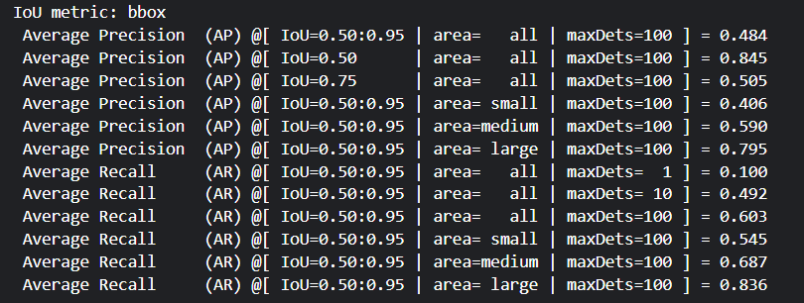

Inference with pre-trained model (checkpoint0033_4scale.pth):

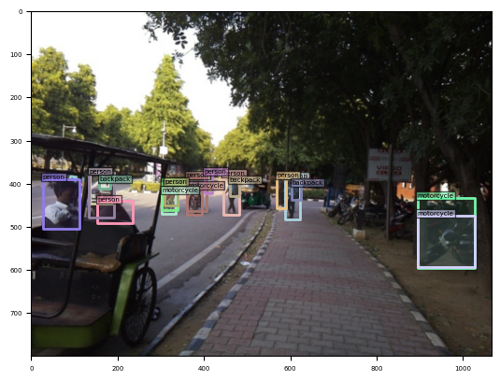

Ground truth:

